1.Write an assembly language program for adding two 8-bit data using 8085 processor.

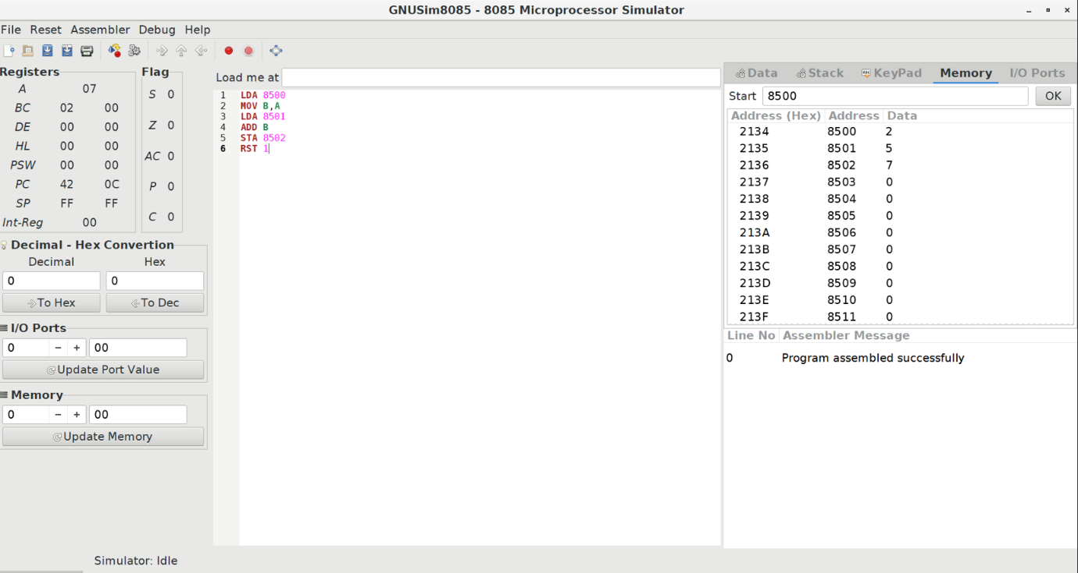

2.Write an assembly language program for subtraction of two 8-bit data using 8085 processor.

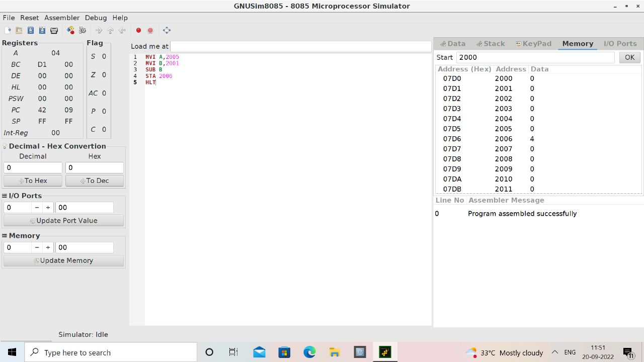

1. Write an assembly language program for adding two 16-bit datausing 8086 processor.

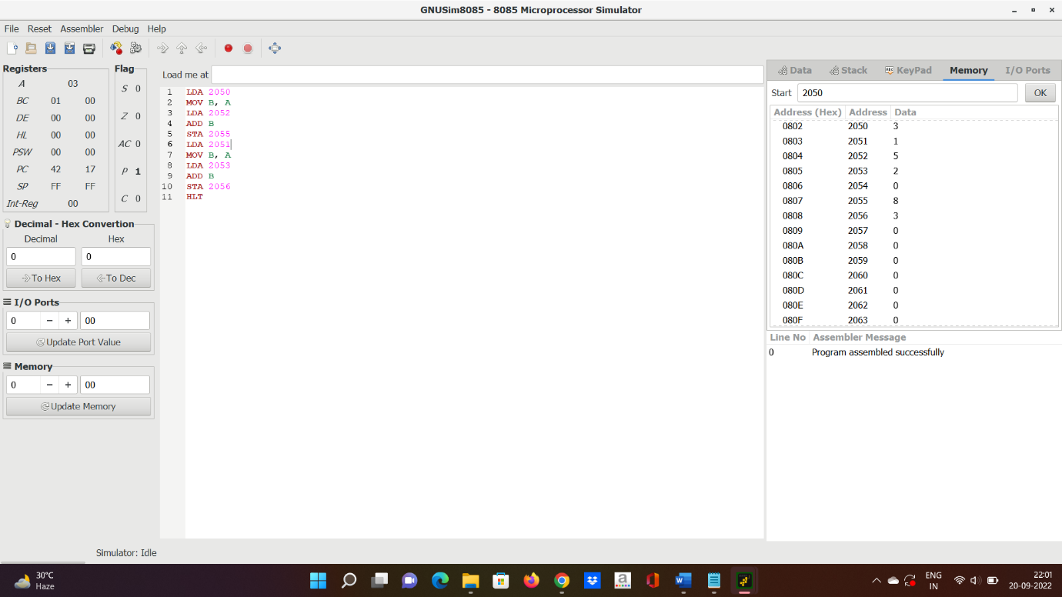

4.Write an assembly language program for subtracting two 16-bit datausing 8086 processor.

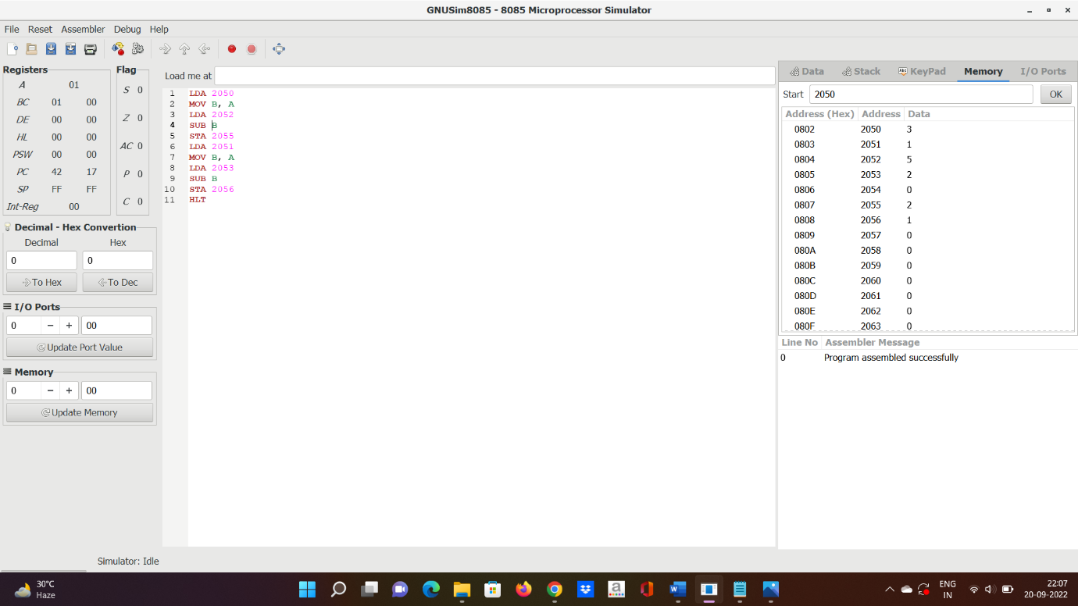

**5.**Write an assembly language program for multiplication of two 8-bit using 8085 processor.

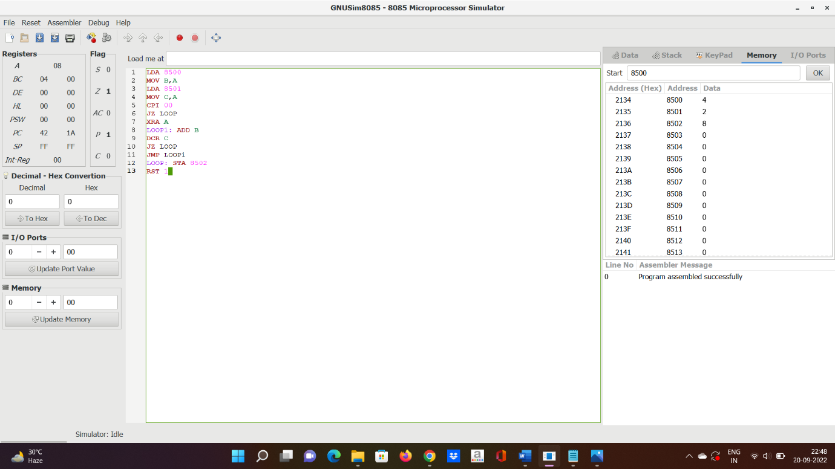

**7.**Write an assembly language program for multiplying two 16-bit datausing 8086 processor

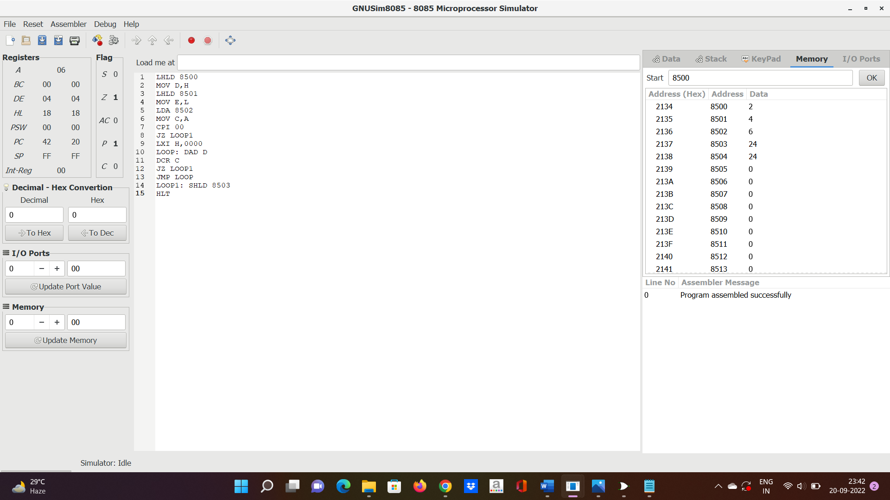

6. Write an assembly language program for division of two 8-bit data using 8085 processor.



8)Write an assembly language program for dividing two 16-bit datausing 8086 processor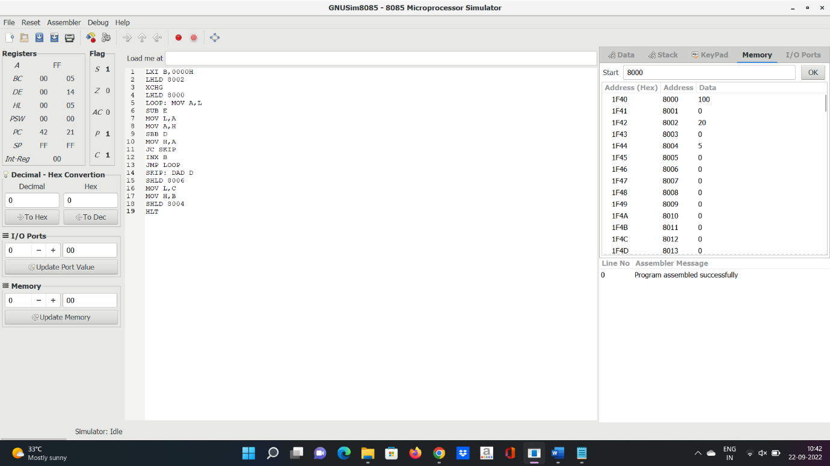

9.Design and implement 2-bit half adder using logisim simulator.

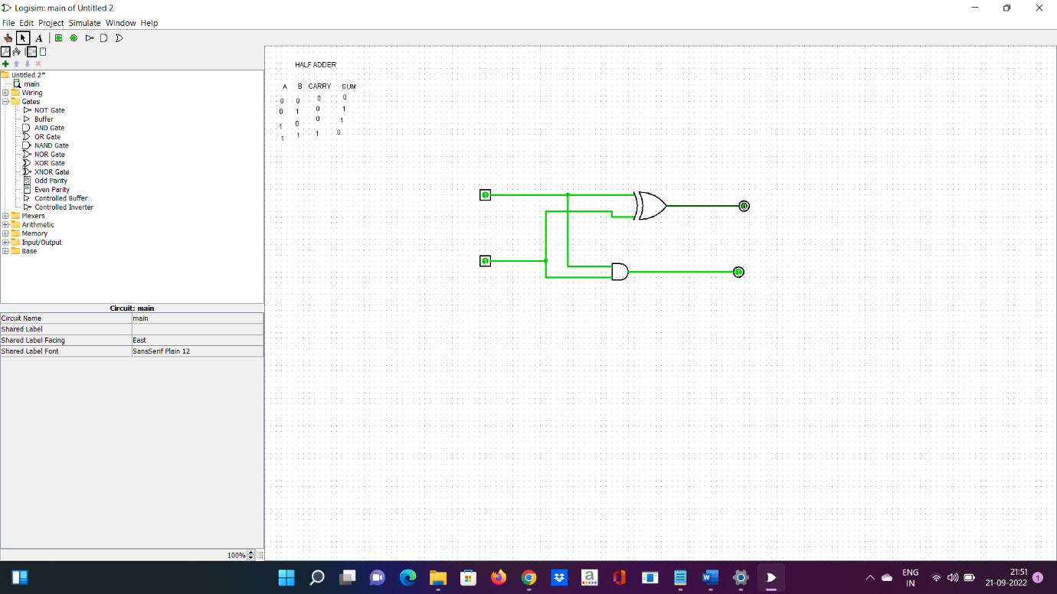

10.Design and implement 3-bit full adder using logisim simulator.

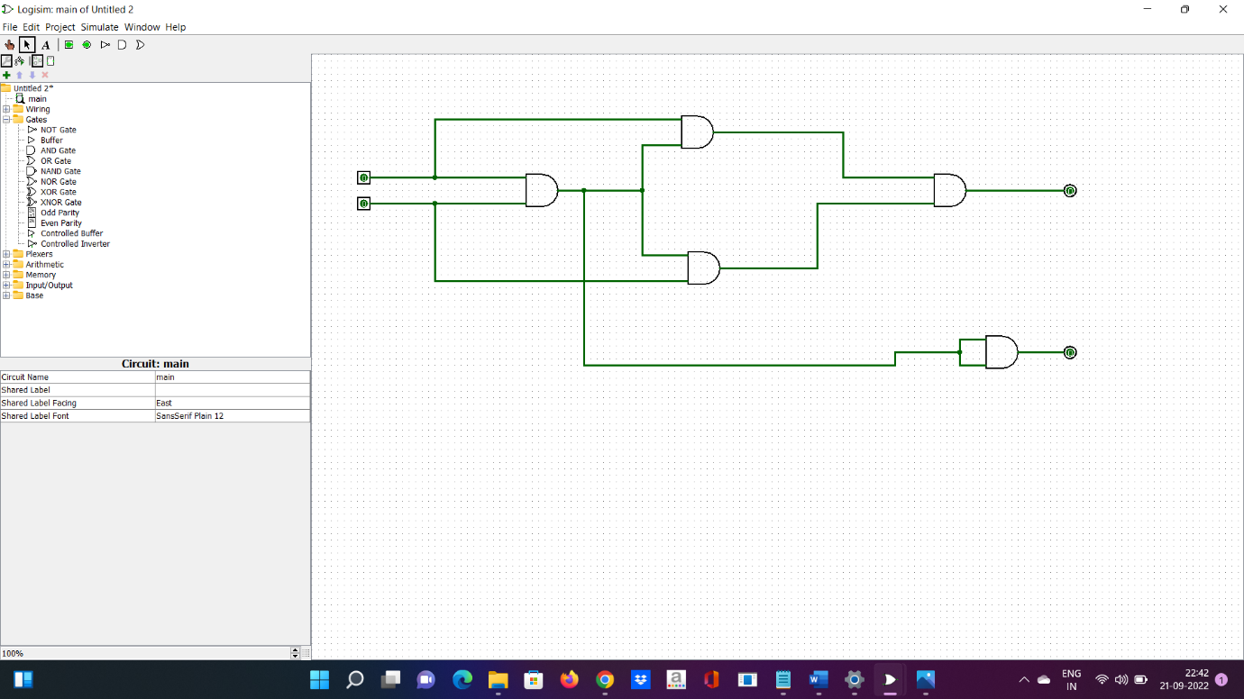

11.Design and implement 2-bit half adder with NAND using logisim simulator.

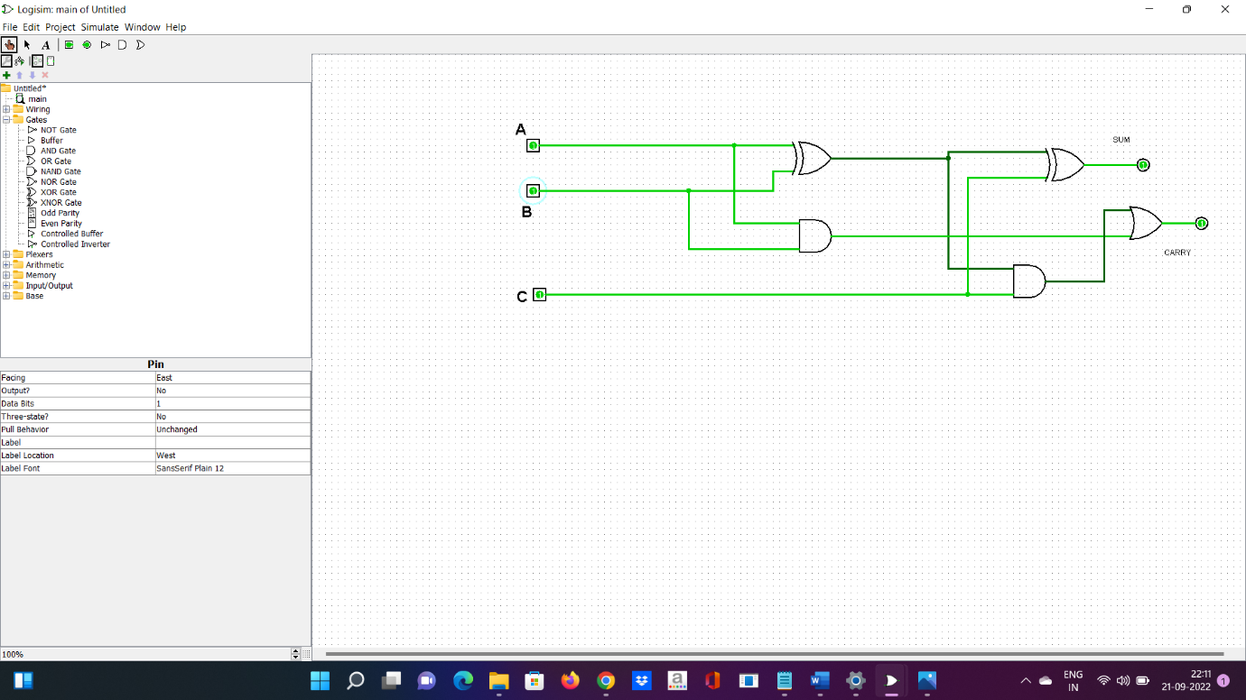

12. Write an assembly language program to find factorial of n in the given number.

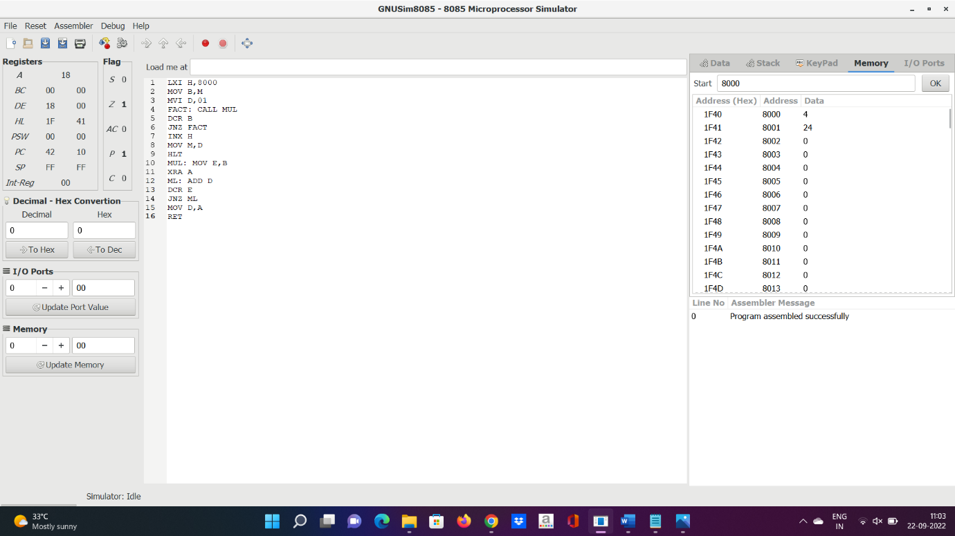

13)Write an assembly language program to find the largest number in an array.

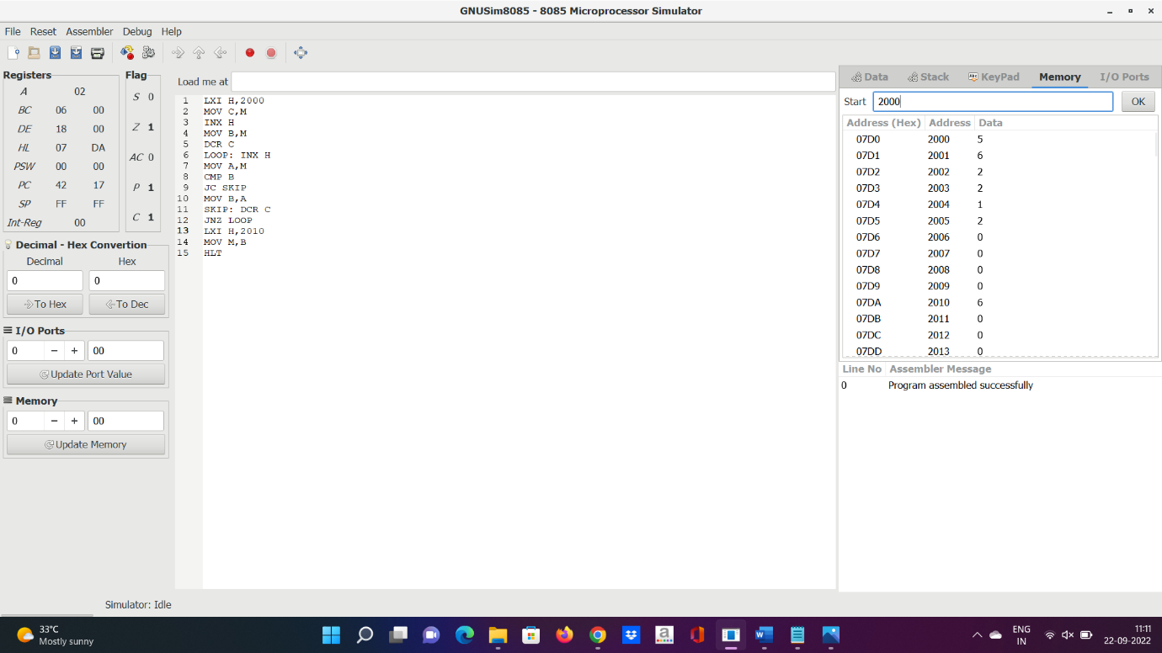

17) Write a program to perform Booth’s multiplication of two signed numbers using any high level language.

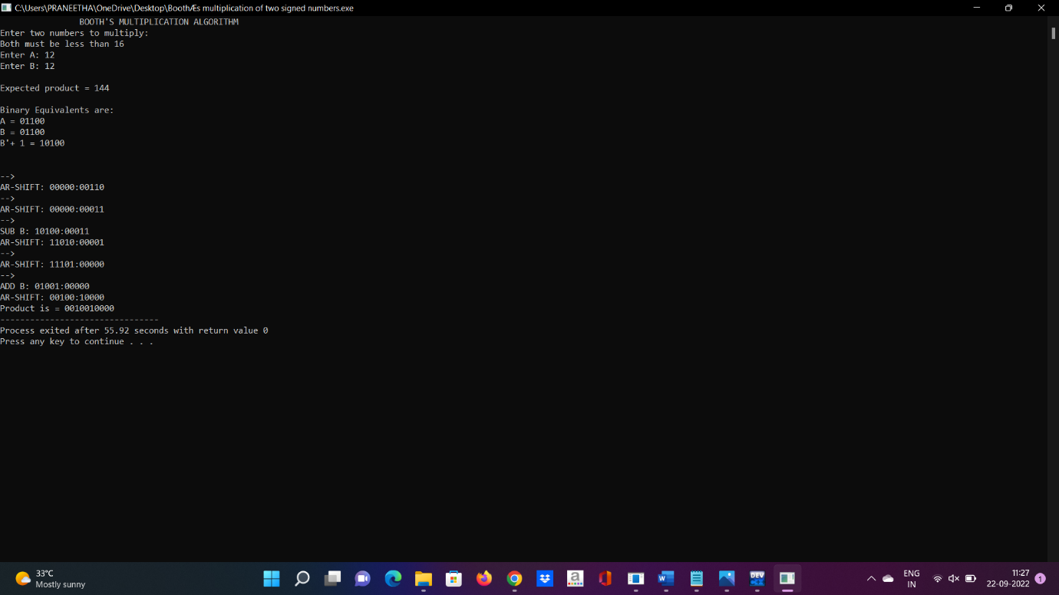

20. Write an assembly language program to find 1’s and 2’s complement of 8 bit number.

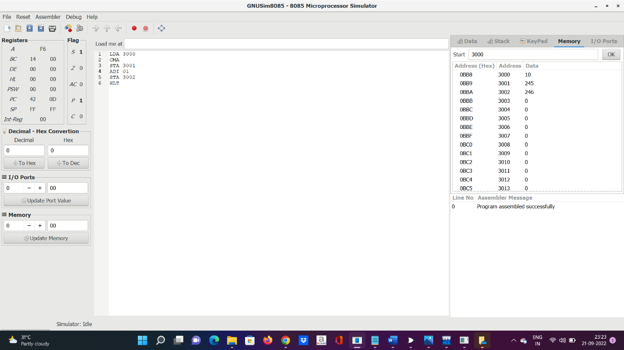

21.Write a program to convert Decimal number to an Octal number using any high level language.

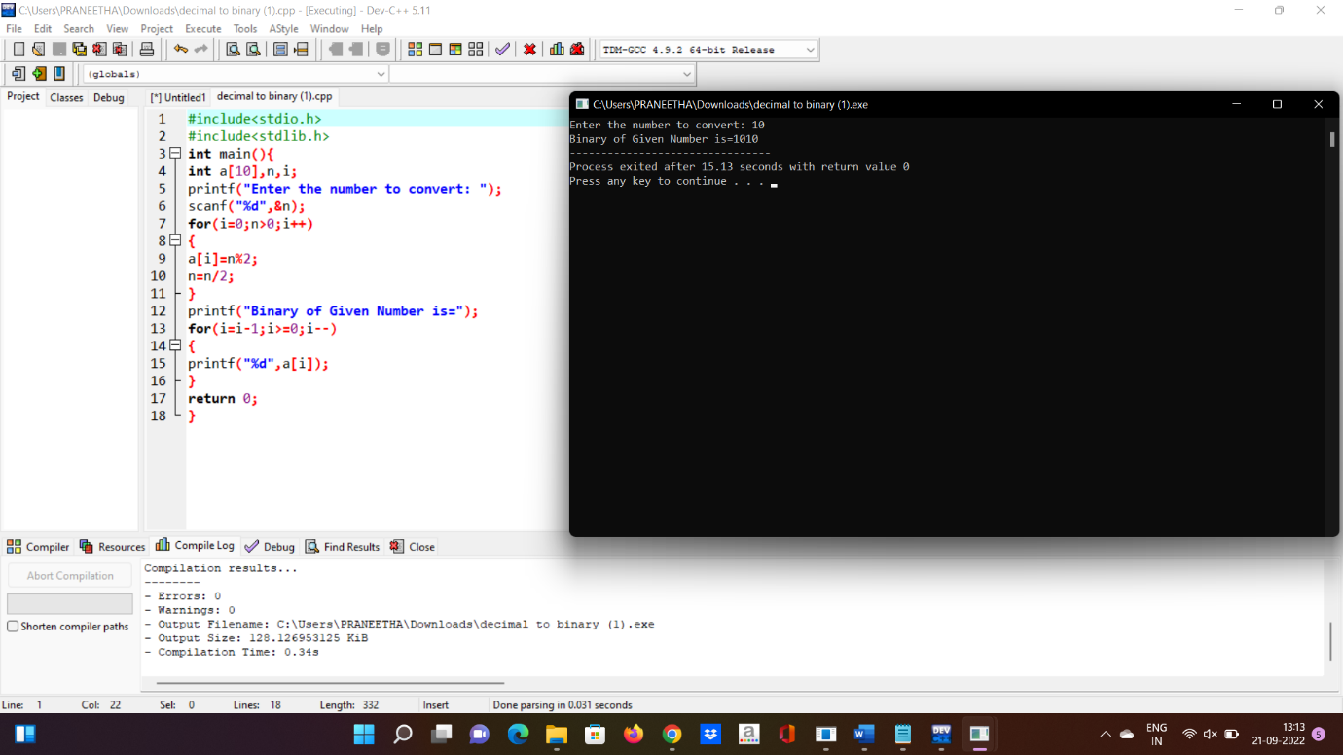

22. Write a program to convert Decimal number to an Octal number using any high level language.

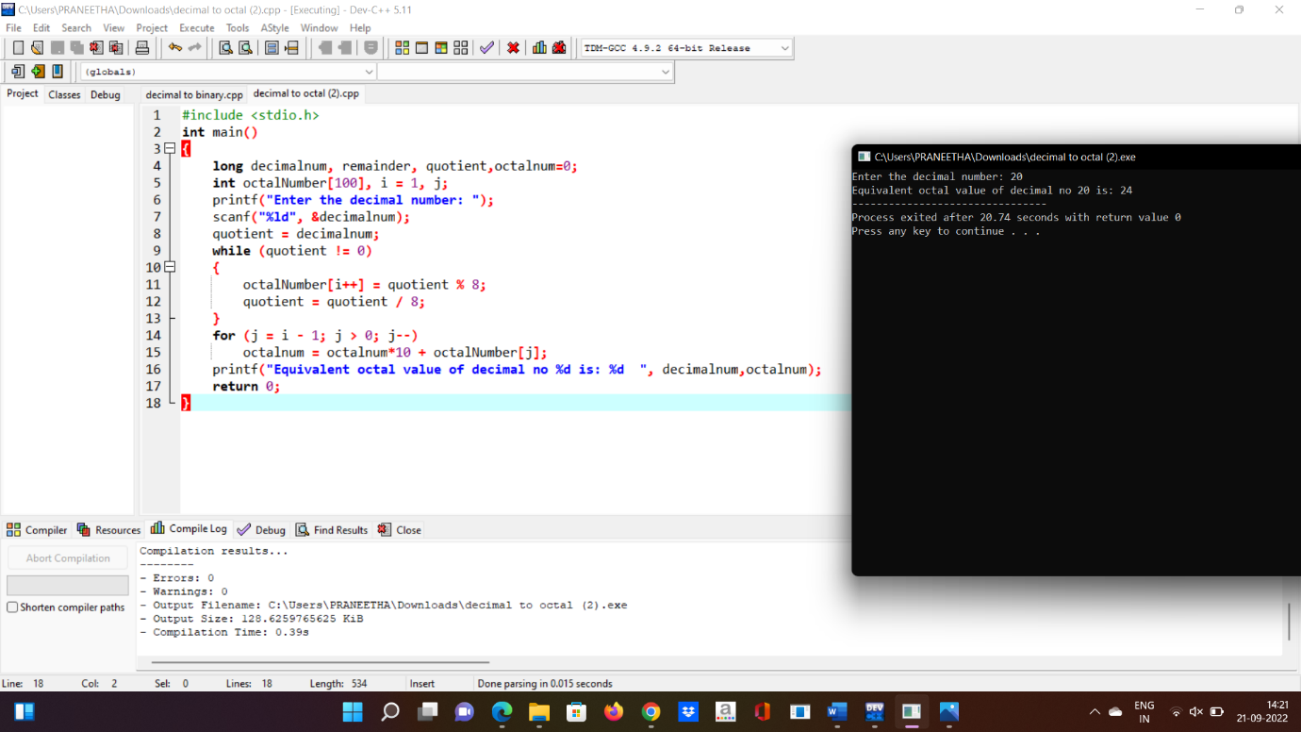

23. Write a program to convert Binary number to Decimal number using any high level language.

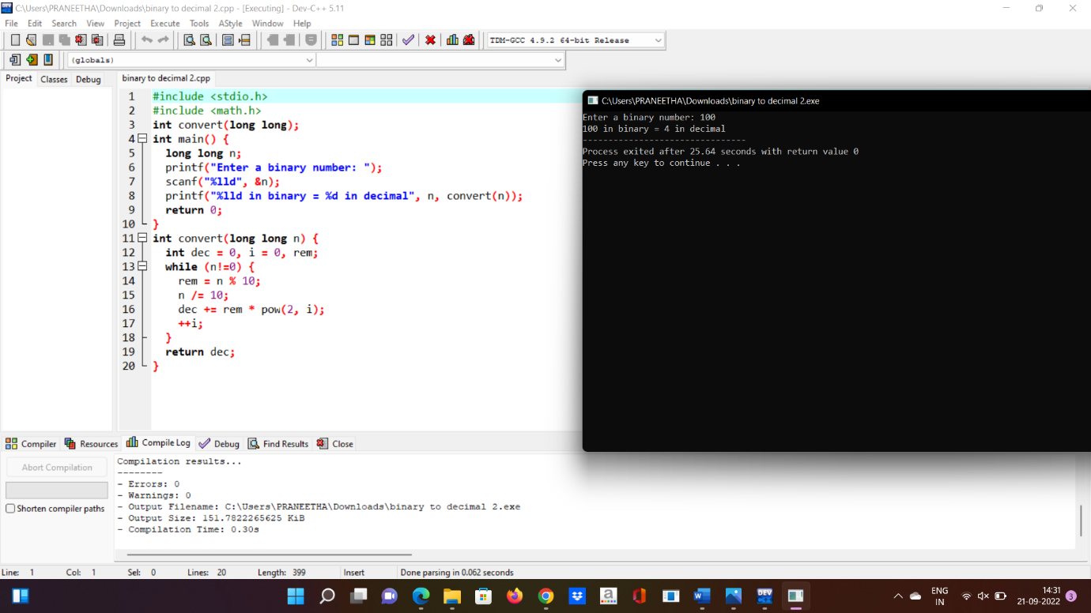

24.Write a program to find the CPU performance of a processor using any high level language.

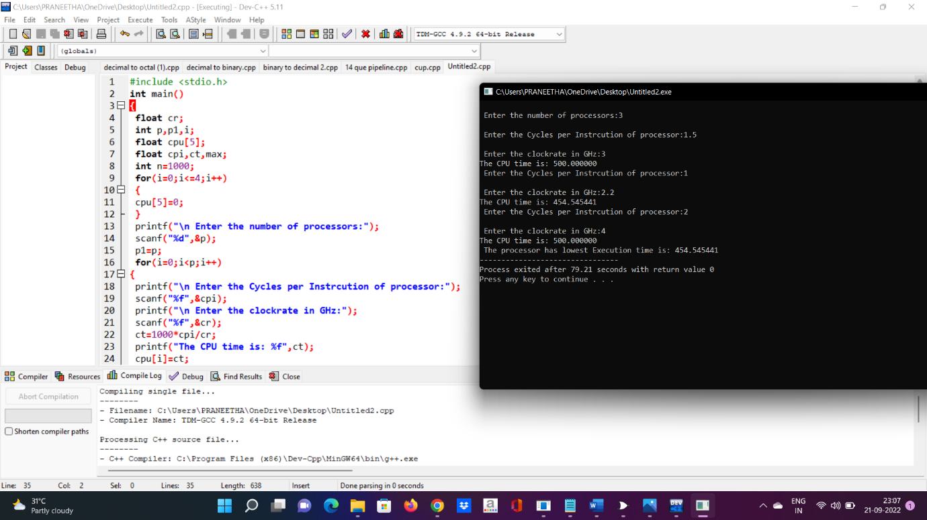

25.Write an assembly language program to swap two 8-bit datausing 8085 processor.

